NEWSLETTER

No. 03, Term 02, Week 05

Monday 28 May 2018

Greetings, Kia ora, Talofa lava, Kia orana, Malo e lelei, Fakalofa Lahi Atu, Namaste, An Young Haseyo, Konichiwha, Bula Vinaka, Sawadee, Dobra Dan, Ni Hao, As-salamu alaykum, Hola

Samoan Language Week
This week is Samoan Language Week. We will be learning about Samoan culture. If you would like to help with this please see your child’s classroom teacher.
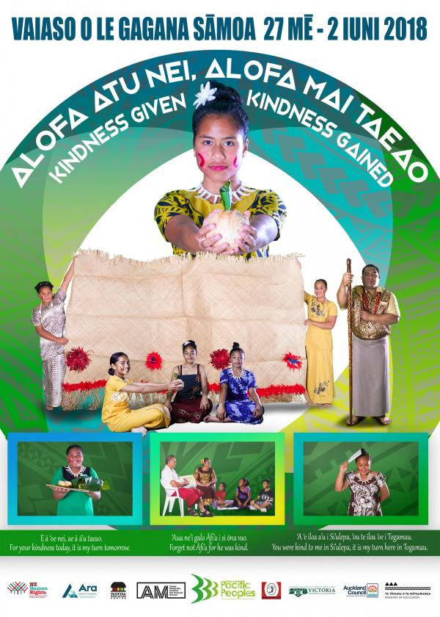

Baking Programme
Every Wednesday the baking programme is held in the school hall. It starts at 9.00am. All welcome.

Queen’s Birthday Weekend
Next week on Monday 04 June, the school will be closed for the Queen’s Birthday.

Cultural Day
To end Samoan Language Week on Friday 01 June, the students are most welcome to dress in their cultural attire. It is an exciting opportunity to observe and celebrate all the cultures.

Eastern Zone Soccer Tournament
Last week Tuesday, our Year 7 & 8 girls took part in the soccer tournament. They were extremely overwhelmed and thoroughly enjoyed their time at the games. The girls were also able to learn and enhance their skills while playing against other schools.
Girls Involved:
Mariann Ares Mariesall Schwenke
Fakatu’a Kaufusi Hayley Pawhau
Kiandra Togafiti Dipasha Prasad
Niukasela Phillips Razel Padayao
Fatima Kaufusi Monalisi Tupou
Patilda Tufafo

ASB Banking
We can now offer school banking. Banking day is on Friday. Forms are located on the Kashin the Elephant bank deposit box in our reception area. When children sign up to open an ASB account, they will be sent a Kashin deposit box and calculator in a yellow bag - all to keep. If you’d like to register your child for free, for this, please see our friendly office staff.
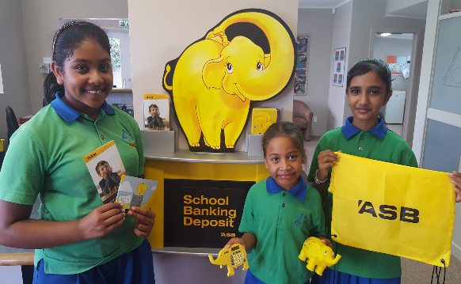

Upcoming Events
Mufti Day is on Friday 08 June.
School Speech Competition on Wednesday 20 June.

Winning House
Congratulations to PURIRI house – our house winner for this week.
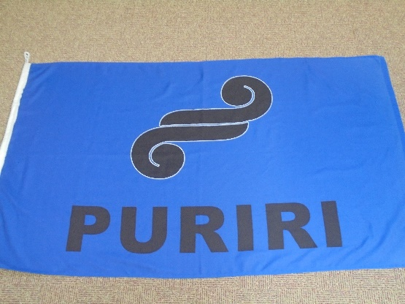

PDS Librarians

Congratulations to our school librarians. You’ll do a wonderful job.

Miceala Lizasoin Ren Razel Padayao

Summa Hepana Monalisi Tupou

Jaymaar Inoncillo Brooklyn Taufa

Zeeshan Baker Kiandra Togafiti

Hinano McQuade Evlyeen Ram

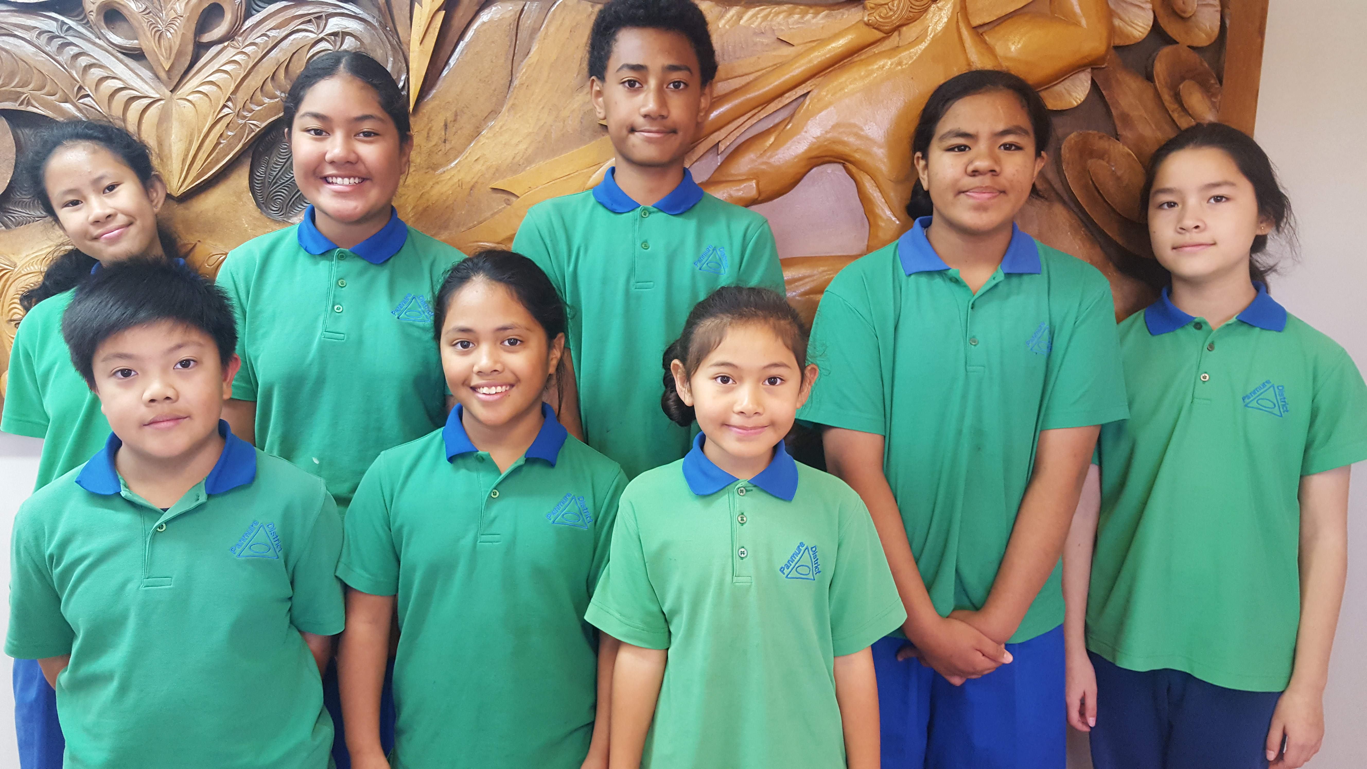

Hockey
This term, children have been practising their hockey skills. Have a look at our future NZ Hockey Players.
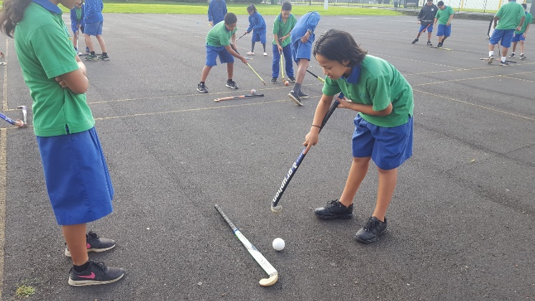

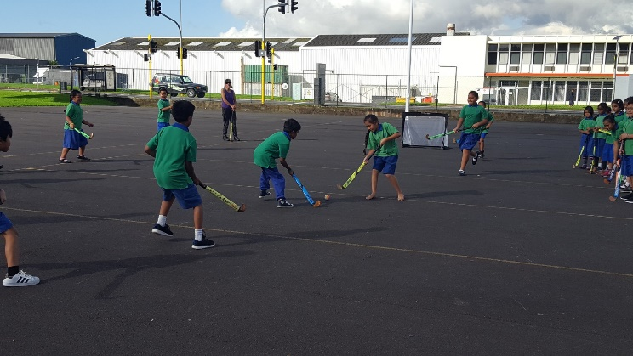

PDS – School Newsletter
# 03 Term 02 Week 05:
I have read the Newsletter.
Child’s Name: _____________________
____________________________
Room No: ____________ Parent’s Signature

Digital Workshop
Have a look at some of our PDS children learning how to programme – The M-Bot
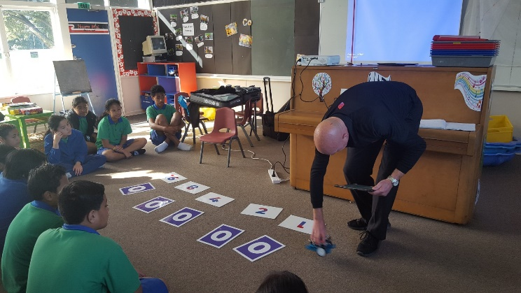

Duffy Awards –
Dontrae Te Maro Malia Ofakineiafu

Lavinia Ma’u Krishan Patel

Sione Ma’u Masooma Faizi

Kartik Patel David Lotufaafetai

Niukasela Phillips Juan Lizasoain Ren

Merit Awards
Room 01 -
Nathanael Mafi for his great interest in learning Maths, Reading and Writing. His behaviour is excellent.
Taison Ng for his excellent work in Maths, Reading and Writing.

Room 02 -
Sanaa Ali for working hard in Maths.
Ezekiel Marsh for using finger spacing and writing neatly.

Room 03 -
Evlyeen Ram for her initiative to help others and to assist whenever she has been asked.

Room 05 –
Monalisi Tupou for using a variety of language features and sophisticated vocabulary to add detail to the text.
Estelle Tauaneai for improving her fluency and accuracy.

Room 07 –
Hazel Godoy for showing perseverance in all her school work.
Ngata Tupou for using a wide variety of appropriate vocabulary in his story.

